Zhulien Mobin - 3191549
My goal was to improve our code, and do lots of testing with the tank events, since the tank was constantly recalibrating movement and not doing enough shooting.
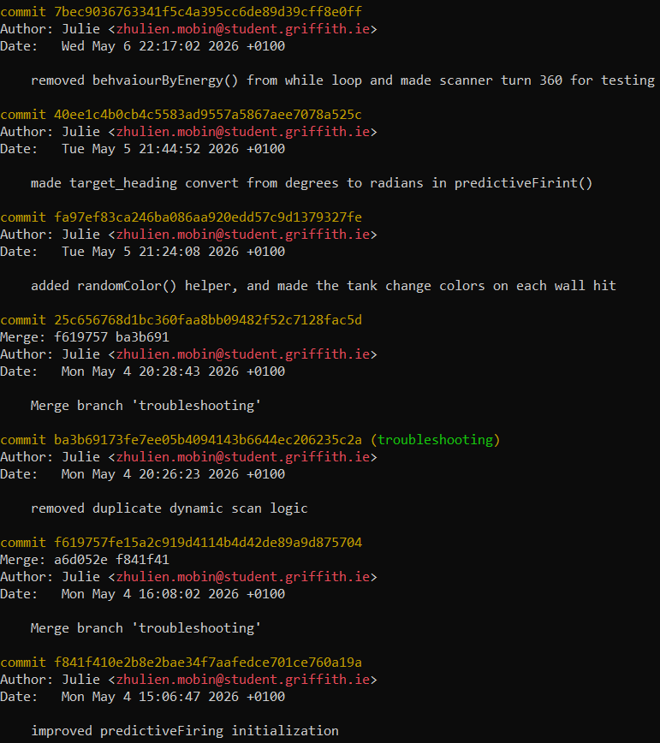
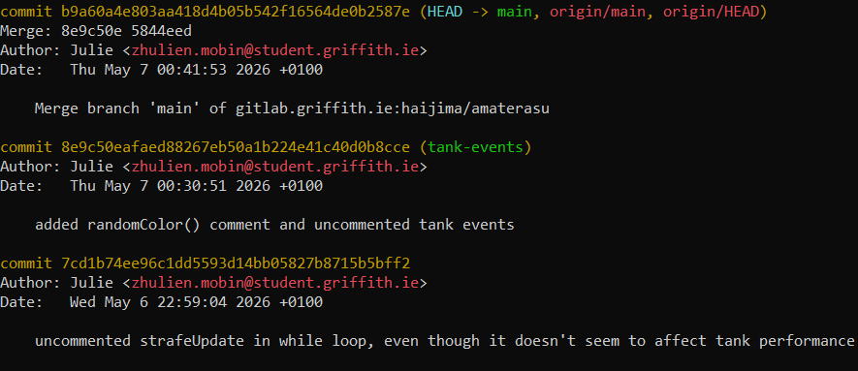

Zhulien Mobin - 3191549

- Improved predictiveFiring() initialization.
- predictiveFiring() now converts target_heading into radians before predicting the enemy’s position.
- Added randomColor() method, which changes our tank’s colors each time it hits a wall.
- Removing behaviourByEnergy() from the while loop and made the scanner turn 360 degrees instead of 30..

From:
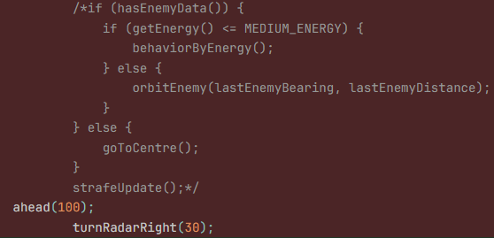
To:
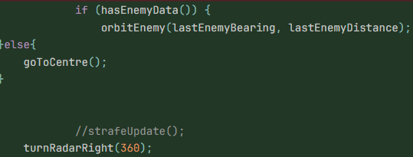

With these changes, I noticed our robot performs well against one to a few robots. But our total score seems to decrease based on how many more robots we're fighting at the same time while onHitRobot(), onBulletHit(), and onHitByBullet() are enabled.

So I did some testing, and here are the results:

While onHitRobot(), onBulletHit(), and onHitByBullet() are enabled results:

- Amaterasu vs Crazy 100 round results
- Amaterasu vs 10 other bots 100 round results
- Amaterasu vs 23 other bots 100 round results

While onHitRobot(), onBulletHit(), and onHitByBullet() are disabled results:

- Amaterasu vs Crazy 100 round results
- Amaterasu vs 10 other bots 100 round results
- Amaterasu vs 23 other bots 100 round results

To conclude, onBulletHit() and onHitRobot() are too aggressive for battles with more enemies, while onHitByBullet() is causing us to misposition.
- The auto fire logic from onBulletHit() is proving to be inconsistent and it's just not worth it.
- The current onHitRobot() logic might perform better if instead of ramming into enemies we play it safer to try and preserve energy all the time.
- Dodging after being hit in a battle with more tanks can get a bit messy, and may trip our tank over. Perhaps increasing the DODGE_COOLDOWN for onHitByBullet() could reduce our tank from getting overstimulated by continuous hits.

GitLab Repository URL

